http://www.kaungkin.com/index.php?option=com_content&view=article&catid=53%3Aabsdfnbs-articles&id=1200%3Apoem&Itemid=102
CASHIER

Written by Eaindra/Ko Ko Thet
Sunday, 23 June 2013 20:24
1
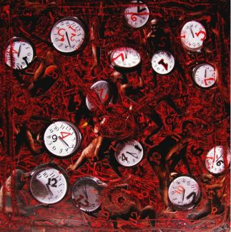
The more I think of him, the more I get repulsive. My abomination swells
like tsunami. My mind itches inch by inch. What smears is he wearing?
What has he been in touch with? What germs and bugs has he got on him?
Are the stains on him his sweat? Does he smell the righteous livelihood?
Where does he come from? Where has he been through? What’s his history?
Is he from a team of presidential bodyguards, or from a tattered begging bowl
in front of a bamboo drum? From a retired teacher’s gardener, or
from Gaddafi’s treasury? Is he just a consequence of karma, God’s will,
or Allah’s blessing? Where does he come from? Does he come clean?
Is his soul sealed? What’s that smell on him? Has he arrived through
Steve Jobs’ latest Apple product, Lady Gaga’s underwear, or the aid programmes
of Shinzō Abe? Has he come from Kim Jung-un’s nuke inheritance, or
from crony businessmen’s charity, or from the clinking of the glasses
at the end of sanctions? How much is he worn out? How many wrongs has he done?
What has he been exchanged for? What’s his hardness? What’s his inflation rate?
Is he a bet? Is he a fine? Is he a graft? Is he a wager? Is he an interest rate?
What’s his skin colour? What’s his mask? How many languages does he speak?
Where does he come from? From the closed-door G-20 summit or from
the suicide note of a bomber? From the giggles of a whorehouse or from
the meal money of a seamstress? From teardrops big and small, from taxation
or natural resources? From compensation, from uniliteral ties or from
pro bono organizations? Where from? Where to? Has he come a long way?
How will he go on? What are the stains and stigmata on him?
The more I think of him, the more I get repulsive. My abomination swells
like tsunami. Shall I kiss him to find out his flavour? The itch of my mind has
just turned into the irrepresssible itch on my palms. The itch of my life …

Eaindra
Translated by ko ko thett
The poem is titled in English. An earlier Burmese version of the poem appeared in The Padauk Bloom
Magazine, January 2012, Myanmar.
Image by Htein Lin

